**US 004-TC 004_001:** **8** **Verify the presence of "ADD TO CART" button.**

Step 1: Navigate to swag labs site

Step 2: Login as "standard_user" into the website

Step 3: Verify the presence of "ADD TO CART" button below each products.

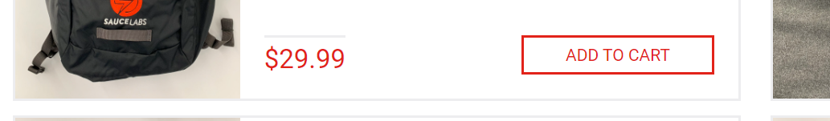

**User is able to see ADD TO CART**

**Test case Passed.**